Statement of Purpose

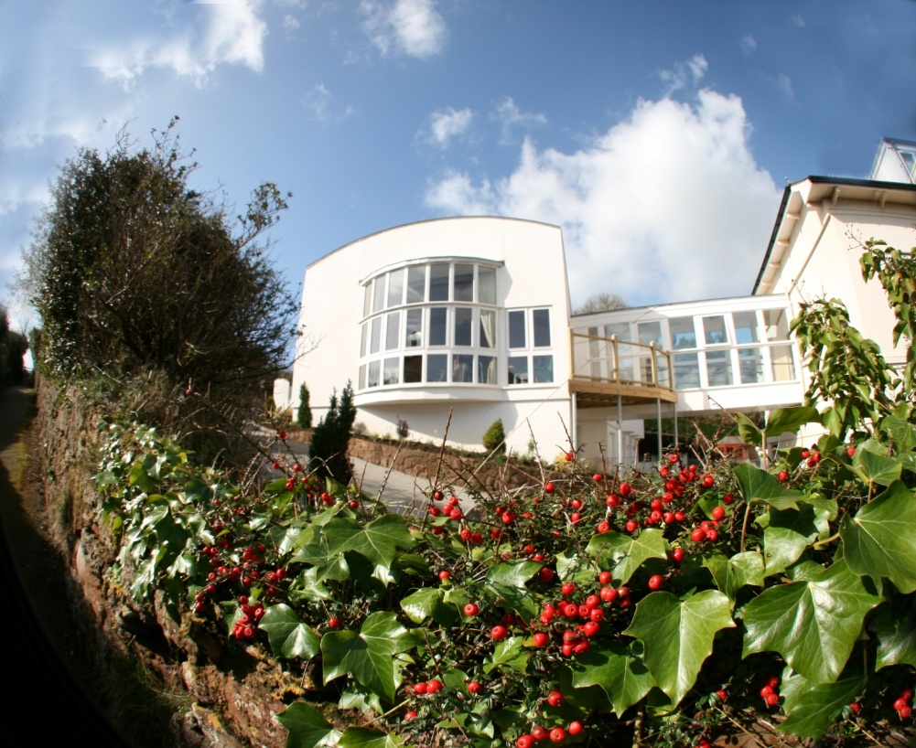

Pinewood Nursing Home
33 Victoria Place, Budleigh Salterton,
Devon, EX9 6JP
Tel: 01395 446161
Fax: 01395 443096
Direct Line Matron Office: 01395 446253
Direct Line Administration Office: 01395 446309

Registered Provider: Elmwood Nursing Home Limited*
Responsible Individual: Mr P Sadeghi

*Registered Office Located at Elmwood Residential Home, Colyford, Colyton, E. Devon, EX24 6QJ

Our Aims and Objectives (the “Pinewood Philosophy”)

Pinewood Nursing Home “Pinewood” is most importantly, a “Home” for the residents who reside with us. For that purpose, it is extremely important to us that residents are allowed freedom of choice, opportunity for self-expression and protection from abuse of any kind. Residents can plan their days as they wish, wear what they want and remain in their rooms or mix with other residents if they want to.

Life in Pinewood is a positive experience in which residents, where possible, are enabled to do more and not less with their lives; to exercise more control and choice; to live in dignity and privacy and finally to have their basic human rights safeguarded.

The Way We Maintain Our Philosophy

The philosophy of care which we practice can be embodied in to six basic values that we believe contribute to the provision of good quality care in our nursing home, namely:

- PRIVACY by which we mean the right of the individual to be left alone or undisturbed and free from intrusion or public attention in to their affairs as they choose. No member of Pinewood can enter a resident’s room without first obtaining that resident’s permission by knocking on their door and securing an approval. Every room is provided with a lockable storage for the resident to keep their valuables under lock and key. We do not cover any loss that may occur to resident’s possessions, but, we will investigate any loss vigorously. All rooms are equipped with locks (the Nurse in Charge of the Home holding a master key).
- INDEPENDENCE by which we mean to have the opportunity to act and think without reference to another person, including a willingness to incur a degree of calculated risk. We will assist a resident when we are asked to do so or when we feel their safety or security is at risk.
- RIGHTS by which we mean the maintenance of all entitlements associated with citizenship. We assist all residents who wish to and are able to vote to register with East Devon Council to exercise their voting rights. Residents are given the choice to vote in person or by post.
- DIGNITY by which we mean the recognition of the intrinsic value of people regardless of circumstance. This is achieved by respecting our residents uniqueness and their personal needs. We treat our residents with respect and address them in the way which they prefer.
- CHOICE by which we mean the opportunity to stay for a trial period and decide on the suitability of the home. To select independently from a range of choices including when to go to bed, when to get up, a choice of food to have at each meal etc.
- FULFILMENT by which we mean the realization of personal aspirations and abilities in all aspects of daily life including the willingness or otherwise to participate in activities, outings and so on.

Residents’ Rooms

Bright and airy accommodation is provided in the home on four floors. Many rooms have en-suite facilities and all rooms benefit from an aid-call bell. We encourage residents to bring in their own furniture and effects to create a real “home from home” subject to our staff being able to properly carry out their function in a safe environment. An eight passenger lift services all of the floors in the home.

There are approximately three double rooms in the home for couples or close friends to use.

Residents are encouraged to take an interest in the world around them, having newspapers delivered and phones and televisions provided in their rooms.

Communal Rooms

Communal activities at Pinewood take place in the Communal Lounge, Dining Room and Day Room. The staff try to maintain a warm, cosy, welcoming family atmosphere at all times, not only for the residents but also for their relatives and friends too. A relaxed, unstressed atmosphere is, therefore, promoted. There is no restriction on visiting times.

There is a CD Music System for resident’s use in both the communal lounge and day room, along with a 50 inch television in the day room and 32 inch television in the communal lounge. A DVD player is available in the Day Room.

Care

Staff at Pinewood are selected primarily on the basis of a kind and caring nature. On-going training is provided to ensure that they have the necessary skills and experience to deliver a high standard of nursing care, utilising the medical equipment and facilities provided by the Home.

Residents care is reviewed at least monthly by the nursing staff with the involvement of GPs and other members of the primary health care team. Pinewood has its own Physiotherapy suite with a resident physiotherapist. Physiotherapy is provided on a complimentary basis for all residents.

Food

It is the aim of Pinewood to sustain and improve resident’s health and well-being. To that end, residents are provided with plenty of freshly cooked food, fresh fruit and vegetables that are sourced to a large extent locally. Beverages and snacks are available at any time of the day or night. Residents are given a choice of nutritious foods each day, supplements can be provided and any special diets catered for.

Set meal times provide an opportunity for residents to meet up and socialise in the communal dining room if they so wish. Alternatively, residents can opt to eat their meals in their rooms. Meals can, nevertheless, be taken any time of the day that a resident wishes. Friends and relatives are encouraged to eat at the Home.

Activities

Residents at Pinewood are encouraged to express themselves artistically and creatively, individually and collectively, according to their preferences. There is a formal recreational programme set up including music and exercise sessions, arts and crafts, singing, musical events, Tai Chi and minibus outings. Pinewood employs an activities co-ordinator who as well as setting up communal activities, also visits residents in their rooms to “just chat”.

Pinewood believes that it is important for residents to retain their independence for as long as possible and assistance is given to residents to continue any social activity they may have had before they resided at Pinewood. As such, we can take residents to any local clubs, pubs or places of interest.

Arrangements can be made for relatives and friends to be collected from the local area so they can visit.

There are regular visits made to the home by local vicars and priests and there is a monthly communion service in the lounge (first Wednesday of each month). Arrangements can be made for leaders of other religious denominations to visit the home if so required.

Delivery of daily newspapers and magazines is made to residents as required.

A chiropodist visits every six weeks. A hairdresser visits Pinewood weekly, but, several residents have their own mobile hairdresser who attends to them in their rooms.

Range of Residents at Pinewood Nursing Home

Pinewood is registered under category “N” with the Commission for Social Care Inspection and it’s registered under service category “OP”. In other words, Pinewood’s residents are mainly over 65 years of age and their physical needs outweigh their mental health needs.

Resident’s Care

It is the aim of Pinewood to provide its residents with the best care possible. A plan of how residents will be cared for at Pinewood (known as a “care plan”) is created within 12 hours of a resident’s admission to the home. Wherever possible, residents care plans are drafted in consultation with residents, their care managers or relatives (the “Care Team”). Care plans are updated on a monthly basis and the Care Team is consulted on the update whenever possible (members of the Care Team will be asked to sign care plans when possible in order to confirm that they have been consulted).


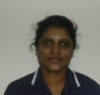
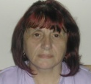
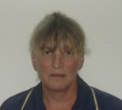


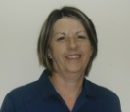

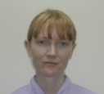


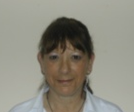




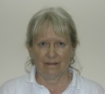



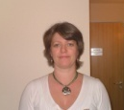

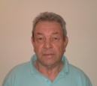
Responsible Individual & Director:
Philip Sadeghi
PA/Receptionist:
Ruth Hespin
Activities:
Shirley Jones
Maintenance:
Philip Weston
Domestic:
John McGinley
Laundry:
Hernando Mercado Leigue
Laundry:
Kelly White
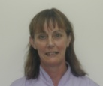
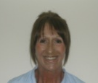




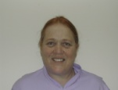
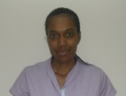

Matron:
Karen Thomas
Deputy Matron:
Eileen Enever
Nurse:
Lesley Dawe
Nurse:
Maria Fampulme
Nurse:
Bindu John
Nurse:
Nisha Sreedharan
Care Team Leader:
Beverley Nottingham
Senior Carer:
Chris Turner
Senior Carer:
Marti Ogobannaya
Senior Carer:
Kishori Mohite
Carer:
Kelly Browring
Carer:
Jenny Olliff
Carer:
Irena Bojiwka
Carer:
Christiane da Silva
Carer:
Debbie Foxford
Carer:
Shirley de Mercado
Carer:
Tracey Porter
Maintenance:
Keith Sigsworth
Kitchen Assistant:
Hannah Teed
Kitchen Assistant:
Ben Hur Revillas
Kitchen Assistant:
Justine Nottingham
Cook:
Sue Poyner
Cook:
Mary Hales
Housekeeper:
Margaret Bailey
Carer:
Sabrina Bellamy
Carer:
Susan Dixon

The Company Directors

Elmwood Nursing Home Limited is a family business. Its three Directors are Jim, Philip and Soroosh Sadeghi. Jim Sadeghi is a Certified Chartered Accountant with a vast amount of experience in management and accountancy. In 1997 Jim purchased Elmwood Residential Home based in Colyton near Seaton. He managed to take that home from being a loss making concern to being a profitable home with an excellent reputation for care throughout East Devon. In late 2003 Jim invited his sons Soroosh and Philip to purchase Pinewood Nursing Home in Devon with him.

Philip had until that time worked as a solicitor in the city of London with over eight years experience in the law. Feeling it was about time for a change of career, Philip agreed to join his father and to be in charge of Pinewood.

In 2006 Jim, Philip and Soroosh purchased Holly Bank House in Churchinford where Soroosh is the Responsible Individual.

Together Jim, Philip and Soroosh Sadeghi have the expertise and experience to run a Nursing Home that is both efficient and a viable business as well as being a friendly, comfortable, caring home to its residents.

Qualified Staff

Karen Thomas (Matron)

Karen qualified as a Registered Nurse (RN) in 2001 having gained a Diploma in Health Studies at the University of Plymouth. Her first position as a staff nurse was on a respiratory ward at the Royal Devon and Exeter Hospital. She stayed there for 18 months before moving to a diabetes ward. She then went on to secure a senior staff nurse role and then a Sister’s role while she was there. During her management position Karen lead the medical directorate drug up-date training sessions for qualified nurse, was a clinical nurse adviser and did night management duties in which she was in charge of the hospital at night. Having decided upon a change Karen came to Pinewood in June 2007.

Eileen Enever (Deputy Matron)

Eileen qualified as a Registered Mental Nurse (RMN) in 1989, having trained at East Surrey Nurse Education Centre. She then initially spent six months on an acute psychiatric ward before commencing a career as a Community Psychiatric Nurse, during which time she undertook a Diploma in Health Studies and BSc (Hons).

Eileen continued to work in the Surrey area until her move down to Budleigh Salterton in 1999 and subsequent employment at a large Westminister Healthcare Nursing Home in Exeter.

In November 2000 Eileen Enever joined Pinewood and became Deputy Matron. She held that position for a year before she decided to take up a Manager’s position in Exmouth in October 2002.

In June 2003 Eileen returned to Pinewood. By May 2005 Eileen had become Matron at Pinewood. In 2007, Eileen decided that she would like to commit more time away from the Home and, therefore, decided to step down as Matron to become Deputy Matron.

Maria Fampulme (Day and Night Sister)

Maria has over twenty years experience as a nurse having qualified in the Phillipines in 1980. She started her career working in Pediatrics and later worked in various surgery wards in the Phillipines. She travelled to Ireland in 2003 and worked in a nursing home in Cork for over a year where she undertook an adaptation course to be able to practice nursing in the United Kingdom. She joined the Home shortly thereafter in 2004.

Lesley Anne Dawe

After completing her nurse training, Lesley initially worked as a staff nurse on general surgery in Southampton General Hospital. She held several sister’s posts in general surgery before moving to elderly care as a ward sister. By 1995 Lesley had left behind the hospital environment to work as Acting Matron at Silver Park Nursing Home in Fleet. A year later she took up a position as Matron at Loadhams Nursing Home in Farnham for two years, and then moved to run Crossways nursing home near Basingstoke. In 2001, Lesley started work as an internal verifier and trainer for Kingsley training as well as her matron’s post. Lesley is now in charge of training staff at the Home including staff NVQ’s.

Bindu John

Bindu qualified as a nurse in India in 1998. She worked in both midwifery and general nursing in hospitals in India and then came and joined Pinewood in 2004 as a care assistant. After having completed her adaptation programme in 2005 Bindu commenced work for Pinewood as a nurse.

Nisha Sreedharan

Nisha qualified as a nurse in India. Joined Pinewood in 2006 as a care assistant and after having completed her adaptation programme in 2007 Nisha commenced work for Pinewood as a nurse.

Care Assistants

Pinewood Nursing Home has a team of dedicated care assistants of varying experience. Each of them have very caring, likeable personalities and have demonstrated an ability to get on well with others.

Beverley Nottingham (Team Leader) | Over 18 years experience as a care assistant. Recently gained NVQ level 3 in Care. Beverley leads the care team at the home.
Martina Ogobannaya | Over 10 years experience as a carer
Chris Turner | Over 17 years experience as a carer
Kishori Mohite | Qualified as a nurse in India in 2001, joined Pinewood in 2006 as a care assistant
Kelly Browring | Over 6 years experience as a care assistant
Debbie Foxford | Over 25 years experience as a carer
Shirley de Mercado | Has one years experience as a carer
Jenny Olliff | Over 12 years experience as a carer
Tracey Porter | Over 9 years experience as a carer
Sabrina Bellamy | Joined Pinewood in 2007 as a care assistant
Susan Dixon | Over 7 years experience as a care assistant. Qualified beauty therapist.
Christiane da Silva

Ancillary Staff
Sue Poyner | Over 16 years experience as a cook
Mary Hales | Cook
Justine Nottingham | Kitchen Assistant
Ben Hur | Kitchen Assistant
Hannah Teed | Kitchen Assistant
John McGinley | Domestic
Margaret Bailey | Housekeeper
Philip Weston | Maintenance
Keith Sigsworth | Maintenance
Ruth Hespin | Receptionist
Hernando Mercado Leigue | Laundry
Kelly White | Laundry

Incidental Expenses

The following charges are made in addition to the fees paid by residents for their residence and nursing care. Pinewood is committed to only charging its residents at cost for the incidental services it provides. The charges listed below are correct as at 1 January 2008:

Hairdressing (provided by the Home’s hairdresser):
Unisex dry cut £6.00
Unisex wet cut £6.00
Shampoo and set £6.50
Cut, shampoo and set £9.00
Cut and blowdry £11.00
Perm £25.00
Colour £25.00

Chiropody:
Price per session £12.00

Physiotherapy:
Per hours session £20.00

Newspapers:
Prices vary, usual charges per week for daily paper £7.50

Opticians:
An optician visits every six months to perform free eye tests. However, unless you are in receipt of income support, you will need to pay for your glasses.

Dentist:
The local dentist will do domiciliary visits but only privately at a cost of £60 a visit (without treatment). Instead, when possible we can take residents to their dentist by car at no extra charge.

Beautician (provided by the Home’s beautician):
Manicure £7.00
Pedicure £7.00
Eyebrow Shape £5.00
Facial Waxing £5.00

The Shop

There is a “Shop” at Pinewood where emergency supplies of toiletries can be bought. We purchase the items for the Shop from local stores and supermarkets and do not charge any mark up to our residents. On occasions we are also able to purchase specific items for residents from local shops at their request.

Telephone

A telephone is supplied with each room. Charges for telephone call are as follows:

Type of Calls | Telephone Number Starting with Digits | Cost of Call in £ per minute
Local Call | 2, 3, 4, 5, 6, 7, 8, 084 | 0.08
National Call | 01, 02, 087 | 0.16
Mobile Call | 07 | 1.35
International Calls | 00 | 3.86
Free Calls | 0800, 112, 999 | 0

We can arrange for a resident’s telephone to only accept incoming calls or to have a direct dial number at their or their relatives’ discretion. We can also arrange for a resident to have a portable phone which can receive a signal within 95% of our building for a deposit of £100.

Annual Development Plan for Quality Assurance

It is the policy of Pinewood to evaluate the quality of care we give and the service we provide on a yearly basis.

The residents and their relatives are encouraged to come in and discuss the care we provide and to complete a care evaluation questionnaire which covers all areas.

In addition we also carry out our own medication audits and review all our care plans monthly.

Staff appraisals are done on a yearly basis. Training provision is also evaluated by the employees (after each training event) so that we can adapt to suit all needs.

At the moment we also carry out a yearly quarterly assurance audit taking in the views of residents, visitors to the home and professionals who have access to the home.

Complaints Procedure

Whilst every care will be taken to ensure that a resident’s stay at the Home will be happy and trouble free, in the event that a complaint becomes necessary the following complaint procedure should be followed:

At the first stage you should raise your concerns with the Home’s Manager. If your concern is not resolved you can then ask for your complaint to be referred to or discuss the matter with Mr Philip Sadeghi the Responsible Individual at the Home who will aim to respond to you complaint within 28 days.

You may also refer your complaint at any stage to:-

Ms Caroline Roland-Lapwood
Regulation Inspector
Commission for Social Care Inspection
Unit D1
Linhay Business Park
Ashburton
Devon
TQ13 7UP
Tel: 01364 651800

Fire Precautions and Associated Emergency Procedures

At Pinewood, the safety of our residents is our paramount consideration. To that end, a fire procedure has been drafted with the assistance of the Fire Bridgade. All staff are trained when they commence their employment so that they understand the fire and associated emergency procedures. Additionally, night staff undertake fire training every three months and day staff undertake the same training every six months.

TERMS AND CONDITIONS OF RESIDENCE
For Pinewood Nursing Home, 33 Victoria Place, Budleigh Salterton, EX9 6JP (the “Home”)

Between: Elmwood Nursing Home Ltd t/a Pinewood Nursing Home (‘Pinewood’) and [name of resident] whereby Pinewood undertakes to provide the Resident residence and care in the Home in room [room number].

- The monthly fee shall be [amount] payable in advance and will cover the provision of all service enumerated in this clause. Any nursing element paid by the Primary Care Trust (‘PCT’) will be in addition to the Fees and are normally collected by Pinewood direct from the PCT. Fees are reviewed on an annual basis by the Home. The services provided for in this clause include:

  - Care;
  - Food;
  - Light;
  - Heat; and
  - Laundry; as required by the Resident.

The Resident shall pay from her own resources, the cost of outgoing telephone calls, dry cleaning, newspapers, incidentals from our shop, chiropody, hairdressing and any medication that the Resident does not obtain by way of prescription. If necessary, Pinewood will pay for these expenses and invoice the Resident monthly at cost. If Pinewood is required to provide transport to the Resident for a distance greater than six miles, Pinewood may charge the Resident travel costs of 40 pence per mile and attendance costs of £5 per hour for the driver.

- The Resident will have unrestricted use of their bedroom.

- The Resident undertakes to advise Pinewood of any valuable item that they bring in to the Home. Pinewood will keep a record of all valuable items, furniture and fixtures belonging to the Resident. However, Pinewood can not be held responsible for the loss of any items belonging to the resident unless they are presented to the Responsible Individual or his representative to be placed in the Home’s safe for safe keeping.

- Pinewood will keep a confidential record of the Resident’s relevant personal information (including health records and a care plan). Access to these records is restricted. However, the Resident, relatives or representatives with the requisite authority (such as persons who have been granted a power of attorney over the Resident’s affairs) and government employees or agents (such as social worker or members of the NCSC with the requisite authority) will be granted access to these records.

- Pinewood reserves the right to terminate this agreement forthwith if in the opinion of the Responsible Individual or the Matron:

  - the care of the Resident has deteriorated to such an extent that it would be beyond the capabilities of Pinewood (having regard to the resources available at the Home at the time such a decision was being considered only) to continue providing proper care to the Resident; or
  - the Resident’s continued stay at the Home would be detrimental to other residents’ quality of life or other residents’ safety.

In either event, Pinewood will do what it considers reasonable to find the Resident alternative accommodation.

- In all circumstances other than already provided for in this agreement, either party must give at least one calendar month’s notice to end this arrangement or alter its terms. Upon the death of the Resident, fees will continue to be payable for a further 14 days.

I understand and agree to the terms stated above:

Signed …………………………...  Philip Sadeghi  Director,  Elmwood Nursing Home Ltd | Signed ………………………………..  Name:  By or for the Resident

Room Sizes

Room Number | Size In Square Meters
1 | 19.70*x
2 | 14.80*
3 | 11.41
4 | 17.90*
5 | 9.20*
6 | 9.90*
7 | 12.37
8 | 12.10
9 | 15.40*
10 | 13.50
11 | 9.70
14 | 13.95
15 | 9.90*
16 | 9.90*
17 | 17.50*
18 | 13.10
19 | 12.60
20 | 12.32
21 | 13.60*
22 | 16.45*
23 | 9.10
24 | 15.60*
25 | 16.60*
Living Room | 28.37
Dining Room | 25.19
26 | 12*
27 | 12*
Quiet Room | 8.3
Day Lounge (Including Balcony) | 27
28 | 12*
29 | 12*
30 | 12*
31 | 12*
32 | 12*
33 | 12*
34 | 12*
35 | 12*

*en suite rooms
x Suitable only for service users who are weight bearing
ADMISSIONS POLICY

A preliminary assessment is made by a Qualified Nurse which identifies all the nursing requirements of the potential resident and also includes Waterlow scores, Nutritional scores and other information about the resident so that there is plenty of baseline information in preparation for the residents admission to the Home. The assessment will also identify whether the resident is suitable for the Home and that the Home can meet all of their needs. The assessing nurse must bear in mind that the process of assessing a resident provides an opportunity to provide the resident (at what can be a frightening time) with a familiar face when the resident arrives at the home.

In the event of an emergency or where it is not practicable to carry out the above assessment in person, the assessing nurse may try to obtain as much of the above information as possible over the telephone from the potential resident, their care managers or other suitable individuals.

The Registered Matron/ Manager or another suitable representative of the Registered Provider, will then confirm in writing that the Home is fully able to meet the resident’s needs.

On admission, a “Patient Details” sheet must be filled in by the Nurse in Charge of the shift. It is particularly important that the next of kin details are recorded on the front sheet and the information transferred in to the admissions book.

Within 12 hours of admission the Manual Handling Assessment form should be completed (even if it is reviewed later on in the week). The care assistants in particular need to know the resident’s manual handling requirements. The assessment is then placed in the resident’s room for all to see.

The care plan is also written within the first 12 hours (ideally the daily report by the nurse on duty at the time of admission should indicate the urgent needs and care required). Any particular routines should also be identified.

Within the first 24 hours the residents clothing and other belongings must be accounted for on an inventory sheet, a copy is then given to the resident and the original should be placed in their notes). The resident’s clothing should also be marked during the first 24 hours and any valuables placed in the Home’s safe.

The resident should be added on to the home’s bath rota within the first week of admission.

Each resident is offered the opportunity to have a daily paper delivered to them and if they so wish, an order should be placed with the local newsagent.

The resident is allocated a “Named Nurse” during their first week at the Home. The Name Nurse is then responsible for reviewing that resident’s care plan and assessments at least monthly.

The Named Nurse should ensure that, in addition to the baseline assessments done during the preliminary meeting, the resident has all the necessary assessments done within the first week of admission.

The assessments that are required are:

1) Dependency Score;
2) Manual Handling Risk Assessment;
3) Waterlow Score;
4) Nutritional Score;
5) Activities Assessment;
6) Wound Assessment;
7) Restraint consent;
8) Care Plan including Risk Assessments;
9) Baseline Observations: temperature, pulse, BP, etc.

Within the first month of admission the relatives are invited to come in and discuss the resident’s care plan (which they then sign). It is also at this point that the resident’s and their relatives should discuss their wishes concerning death and dying which should be incorporated in to their care plan.

It is also an opportunity for the resident to identify the Named Nurse and key workers involved in their care.

